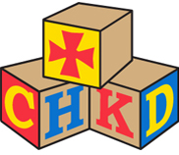
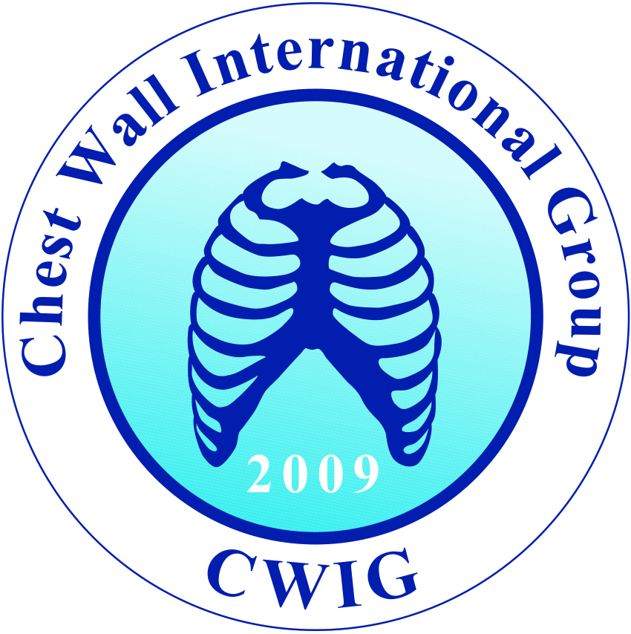

CHEST WALL INTERNATIONAL GROUP 2016
Norfolk, Virginia

Wednesday, June 15, 2016

7:00 am Registration /Continental Breakfast

8:00 am Pre-test (to be completed via web)

8:05 am Welcome Dr. Robert E. Kelly, Jr./Dr. L.D. Britt

8:10 am Keynote Address: Chest Wall Deformity Dr. Donald Nuss (Norfolk, US)

9:00 am Innovation and Chest Wall Problems Professor Hyung Park (Seoul, Korea)
(including video)

9:45 am Break (coffee/juice bar available)

10:00 am Adult Pectus Repair including video Dr. Dawn Jaroszewski (Phoenix, US)

10:45 am Virtual Reality and Chest Wall Problems Professor Rick McKenzie (Norfolk, US)

11:15 am Questions and Answers, morning session

12:00 pm Lunch

1:00 pm Experience at Beijing Children’s Hospital Professor Zeng/Dr. Chen (Beijing, China)
(including video)

1:45 pm Cardiopulmonary Effects of Pectus Deformities Professor Hans Pilegaard (Aarhus, Denmark)
(including video)

2:30 pm Break (coffee/tea bar available)

2:45 pm Vacuum Bell Treatment of Pectus Excavatum Dr. Robert J. Obermeyer (Norfolk, US)
(including video)
3:15 pm Genetics of Pectus Deformities Dr. Christine Garcia (Dallas, US)

3:45 pm Avoiding complications Dr. Andre Hebra, (Charleston, SC, US)
(including video)

4:15 pm Questions and Answers, afternoon session

4:30 pm CWIG Executive Committee Meeting; poster setup for those contributing posters until 6:30pm

6:30 pm CHKD Welcome Reception Lt. Governor of Virginia, Dr. Ralph Northam

CHEST WALL INTERNATIONAL GROUP 2016
Norfolk, Virginia

Thursday, June 16, 2016

7:00 am Continental Breakfast

8:00 am Unusual Variants of Chest Wall Deformity Dr. Patricio Varela (Santiago, Chile)
(including video)

8:45 am Results at our Center over the Last 10 Years: Dr. Robert E. Kelly, Jr. (Norfolk, US)

9:15 am Body Image and Chest Wall Deformity Dr. Michele Lombardo (Norfolk, US)

9:45 am Break (coffee/juice bar available)

10:00 am Pediatric Chest Wall Tumors Dr. Michael LaQuaglia (New York, US)
(including video)

10:45 am Adult Chest Wall Resection for Tumor Dr. Cosimo Lequaglie (Vulture, Italy)
(including video)

11:30 am Questions and answers, morning session

12:00 pm Lunch

1:00 pm Brace Treatment of Chest Wall Deformity/ Professor Davi Haje (Brasilia, Brazil)
Scoliosis and Chest Wall Programs
(including video)

1:45 pm Abramson/Reverse Nuss Operation Professor Mustafa Yuksel (Istanbul, Turkey)
For Carinatum (including video)

2:30 pm Break (coffee/tea bar available)

2:45 pm Imaging of/treatment of chest wall deformity Professor Marcelo Ferro (Argentia)

3:15 pm New Methods of Imaging Dr. Manual Lopez (St. Etienne, France)

3:45 pm Questions and answers, afternoon session

4:15 pm CWIG Business Meeting

5:15 pm Adjourn

7:00 pm CWIG Gala Dinner Dr. Donald Nuss (Norfolk, US)
Half Moone Cruise and Celebration Center

CHEST WALL INTERNATIONAL GROUP 2016
Norfolk, Virginia

Friday, June 17, 2016

7:00 am Continental Breakfast

8:00 am Introduction

8:15 am Various techniques of the Nuss Procedure

8:30 am Open Repair of Pectus Excavatum
(Modified Ravitch Repair)

8:45 am Nuss Procedure after previous failed Dr. M. Ann Kuhn (Norfolk, US)
Ravitch procedur

9:00 am Management of Pectus Arcuatum
(Currarino-Silverman Deformity)

9:15 am Nuss Procedure with Concomitant heart
or aortic surgery

9:30 am Management of Poland’s Syndrome

9:45 am Techniques of Sternal Elevation Dr. Frank-Martin Haecker, Basel, Switzerland

10:00 am Break (coffee/juice bar available)

10:15 am Custom Implant Dr. Frazier Frantz (Norfolk, US)

10:45 am Repair of Sternal Cleft

11:00 am Chest Wall Trauma: controversies Dr. Jay Collins (Norfolk, US)

12:00 pm Lunch

1:00 pm Paper Presentations

2:00 pm Break (coffee/tea bar available)

2:15 pm Paper Presentations (continued)

4:00 pm Conclusion

Evening Activities – Harbor Park Baseball Game, Faculty Dinner

