Simulation Enhanced Learning Course for Paediatric Surgical Trainees
Course Objectives
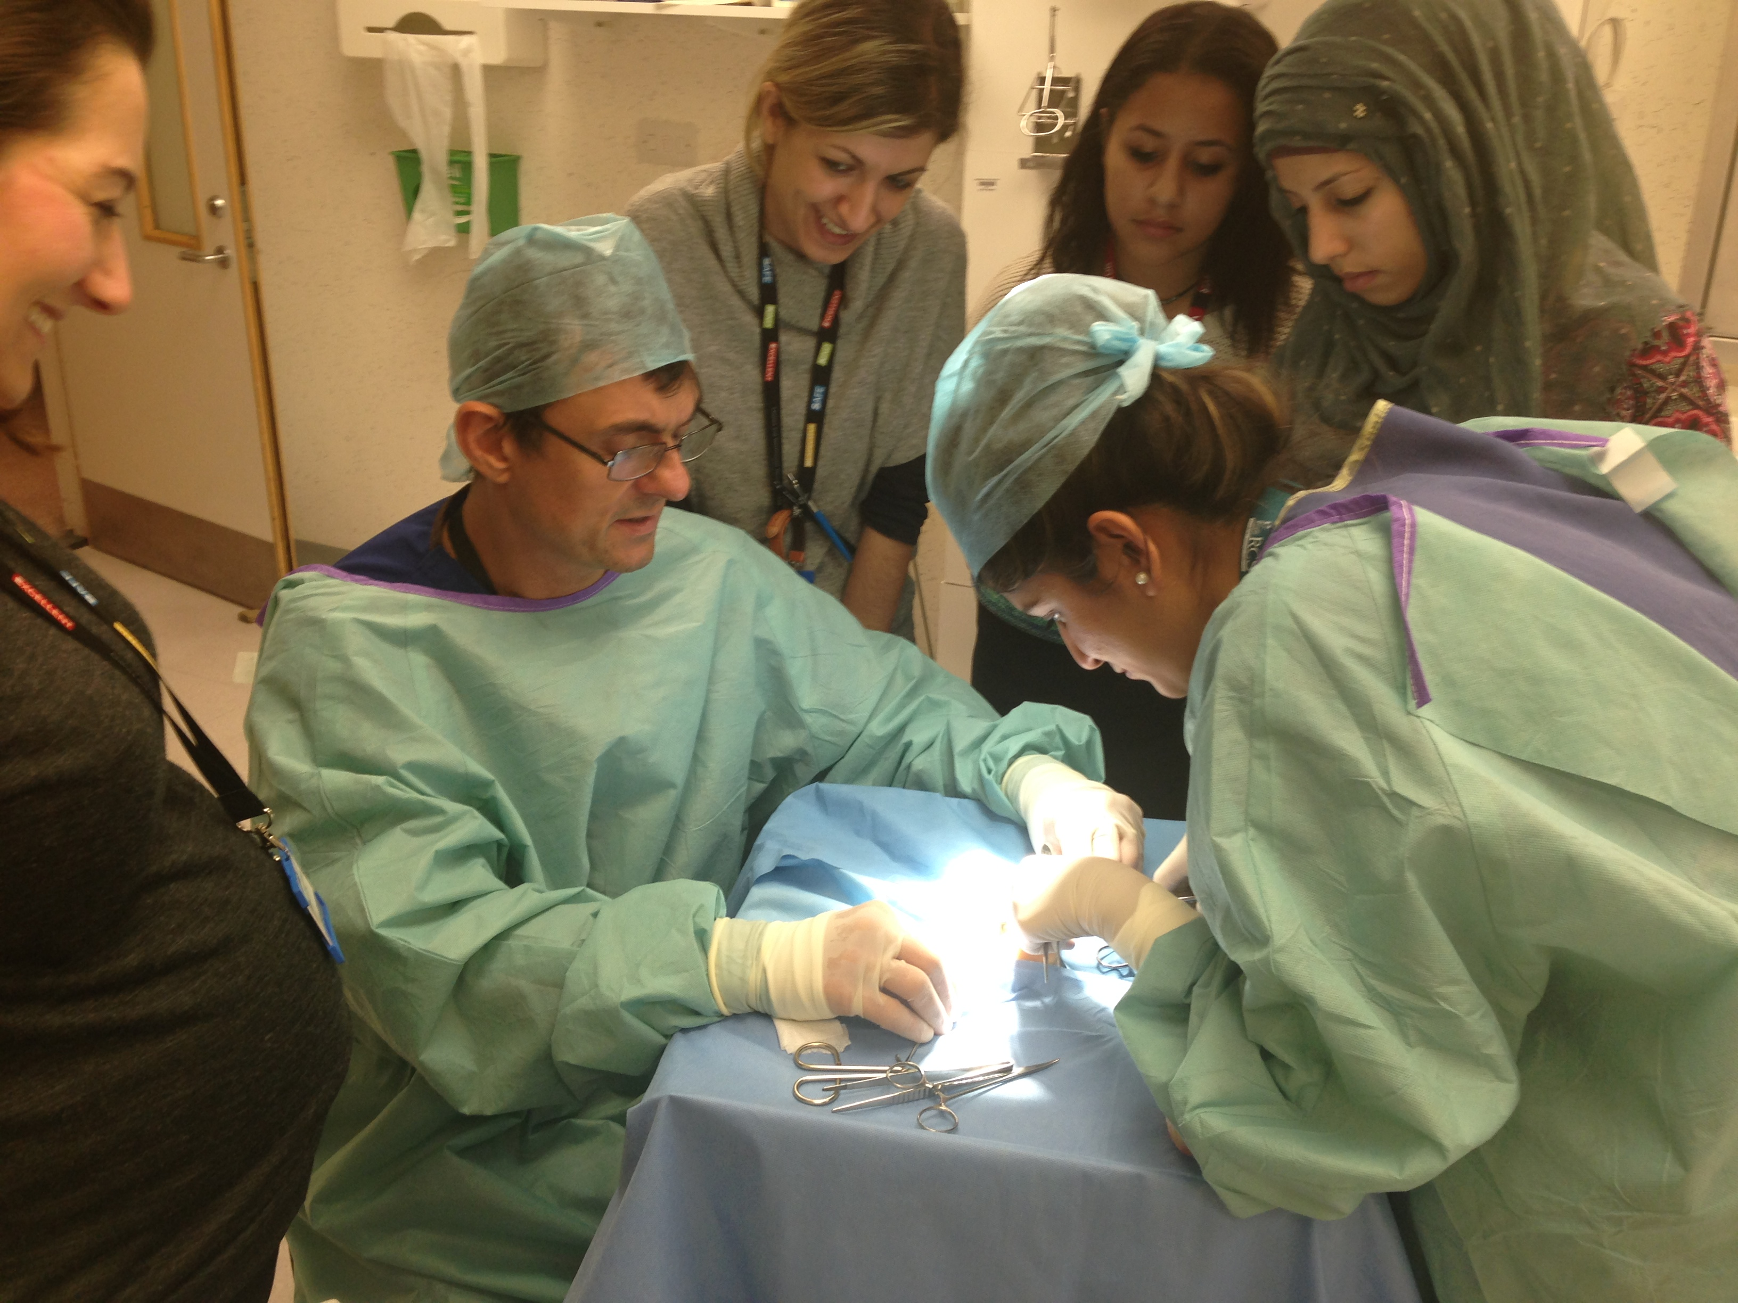
- This low cost course is aimed at providing entry level Higher Paediatric Surgical trainees ST3 or those trainees returning after an extended leave of absence eg maternity or research , with an introduction/ revision of key skills and topics required for higher paediatric surgical training program in the UK and NI.
Course Dates : 5th & 6Th October 2018
Venue :
- Clinical Practice Centre Chelsea & Westminster NHS foundation Trust, 369 Fulham Road, Chelsea. London. SW10 9AH
- To reserve a place email :
simulation@chelwest.nhs.uk or Tel : 020 7351 8971
Topics Covered:
- How to engage with the ISCP effectively
- How to prepare for your ARCP
- How to complete a discharge summary and clinic letter
- Running a ward round effectively / Learning how to prioritise
- Booking and facilitating a theatre list for emergency , general , urology and Oncology lists
- Gastroschisis – bedside bowel management +/- silo
- How to give an effective Rectal washout
- How to do a suction rectal biopsy
- Basic surgical skills eg bowel anastomosis & stoma formation
- Managing the acute neonate from taking referral to booking case including transfer and liaising with consultant on call
- Gastrostomy & jejunostomy tube management : tips and tricks
- Catheterising neonates and small infants : tips and tricks
- Xray interpretation eg NEC perforation , Upper GI contrast for Malrotation
- Management of acute scrotum from referral to surgery
- Management of intussusception reduction
- Suprapubic catheters
- How to avoid burn out / looking after your health as a Specialist Trainee
- Difficult inpatient / outpatient scenarios / on call communication skills
- Management of the patient with ingested foreign body

