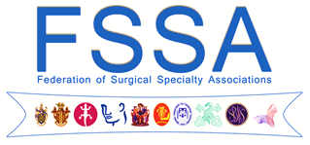

SURGEONS in DIFFICULTY

Date: Thursday 21 March 2019
Venue: RCSEd, 85-89 Colmore Row,
Birmingham, B3 2BB

Surgeons in Difficulty

The recently formed Confederation of British Surgery together with the Federation of Surgical Specialty Associations are hosting a day meeting entitled “Surgeons in Difficulty “on March 21st 2019.

Surgeons today work in a litigious environment and may be subject to investigation from a number of different sources. These include their employer (usually a Trust) the regulator (the GMC) or as a result of complaints arising from allegations of medical negligence (the civil courts).

Whatever their origin, complaints cause considerable stress and anxiety.

The aims of this meeting are:

- To provide a background to medicolegal issues in the UK

- To explain the various processes involved in dealing with complaints

- To advise on the optimal means of avoiding conflicts

- To advise on how best to protect yourself

- To understand what is required of an expert witness
Surgeons are often asked to be expert witnesses and recent experience has shown that it is essential that the clinician writing reports understands both the law and the requirements of the courts. This course will provide an over view of those elements as well as providing some insight into the challenges facing a surgeon in difficulty.

We have put together a programme in which we are fortunate to have a number of experienced and entertaining speakers. There will be opportunities during the day to mix with speakers and colleagues for mutual benefit.

The provisional programme is shown overleaf:

1000-1030  1030 | Registration and Coffee  Introduction and welcome  Professor John MacFie, Past President of FSSA and Inaugural President of CBS
Session 1 – A bit of background….
1040 | Medico legal aspects of practice  Professor Keith Syrett, Professor of Health Law and Policy, University of Bristol
1100 | Medical Manslaughter: what you need to know  Professor Pete Sagar, Colorectal Specialist who acted as an expert witness for the defence  in the Sellu case
1120 | NHS Resolution: role, remit and responsibility  Mr Stephen Preece, NCAS
1145 | Panel discussion
1230-1330 | Lunch and networking
Session 2 – Dealing with the Accusers
1400 | The Trust  Mr Paul McAndrew, Deputy Medical Director and Responsible Officer
1420 | The GMC  Mr John Smyth, GMC Assistant Director – Case Examiner Team
1440 | Coroners Court  Mr Mark Lucraft QC, Chief Coroner of England & Wales
1500 | The Civil Claim  Ms Clare McNaught, Consultant Colorectal Surgeon and Council Member of RCSEd
1520 | Panel discussion
1540-1600 | Coffee/Tea
Session 3 – Some things worth knowing
1600 | Medical Indemnity: reducing your risk  Mr Nigel Mercer, Consultant Plastic and Reconstructive Surgeon, President of the FSSA
1615 | Report Writing: what the barrister wants to know  Mr Nicholas Peacock, Barrister
1630 | Panel discussion
1700 | Drinks & Canapes
1730 | Close
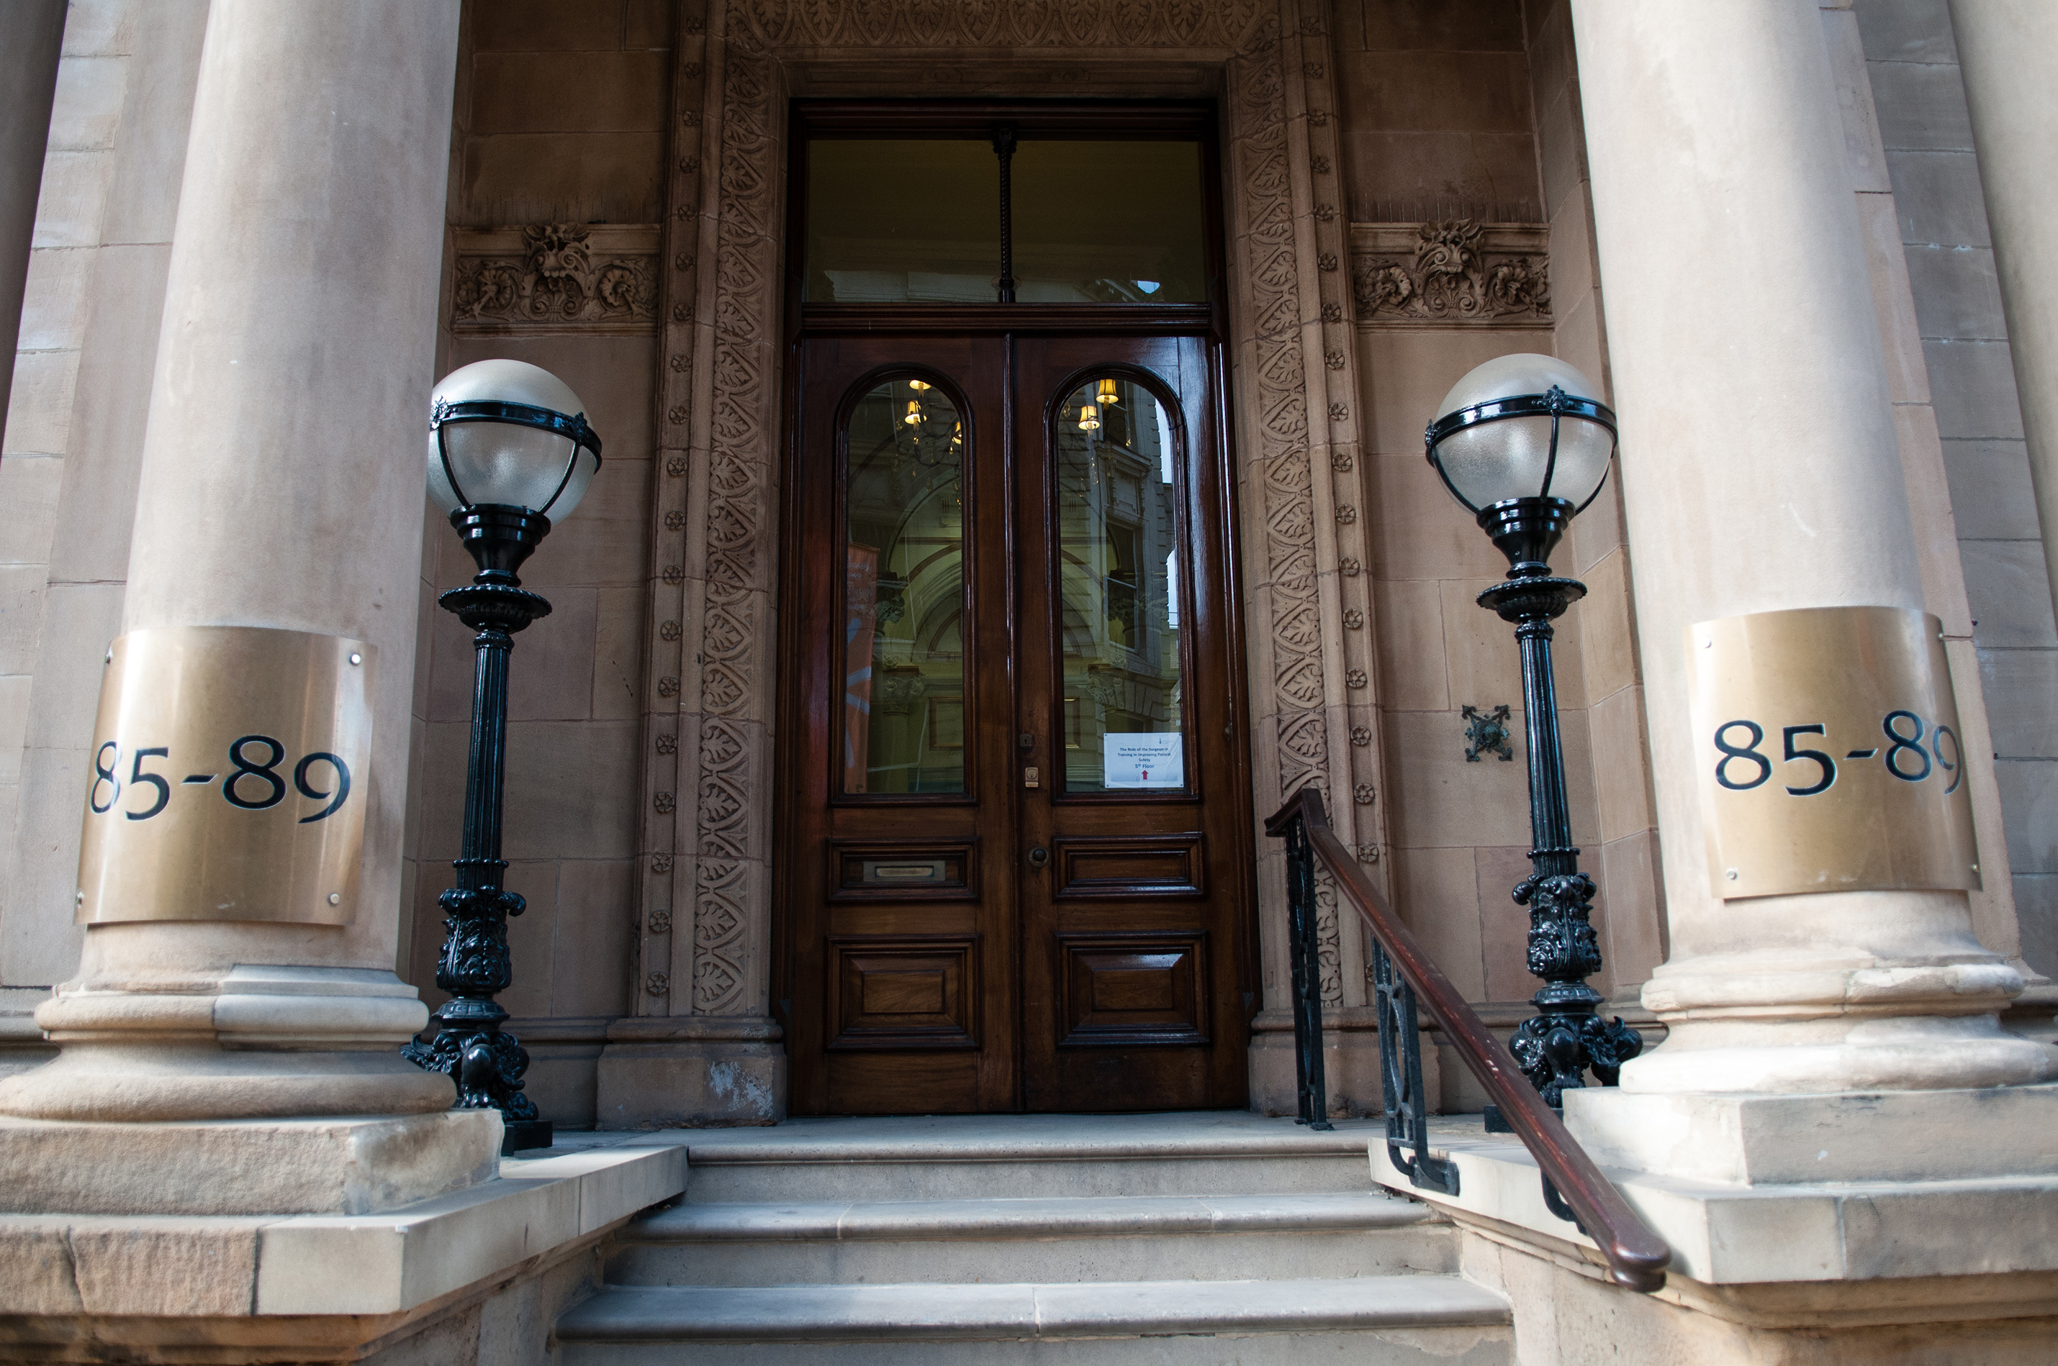

The venue is in the RCSEd offices in Colmore St, Birmingham. This facility was opened in 2014 and offers state of the art office space and facilities for events and courses. It is very conveniently situated close to both major road and rail networks.

Registration:

The registration fee for the day is £125 (£100 for members CBS).

Please complete the following and return to Mrs Carolyn Capps,
232-242 St Vincent Street, Glasgow G2 5RJ. E-mail: admin@cbsgb.co.uk

Name:
Place of Work:
Job Title:
CBS membership no (if applicable):
E mail address:

Please pay registration by BACS to
Account: Confederation of British Surgery
Bank: Bank of Scotland/Lloyds
Account number: 17284266
Sort code: 80 22 60
Reference: Your name

Or by cheque made payable to the ‘Confederation of British Surgery’.

