Simulation Enhanced Learning Course for Paediatric Surgical Trainees

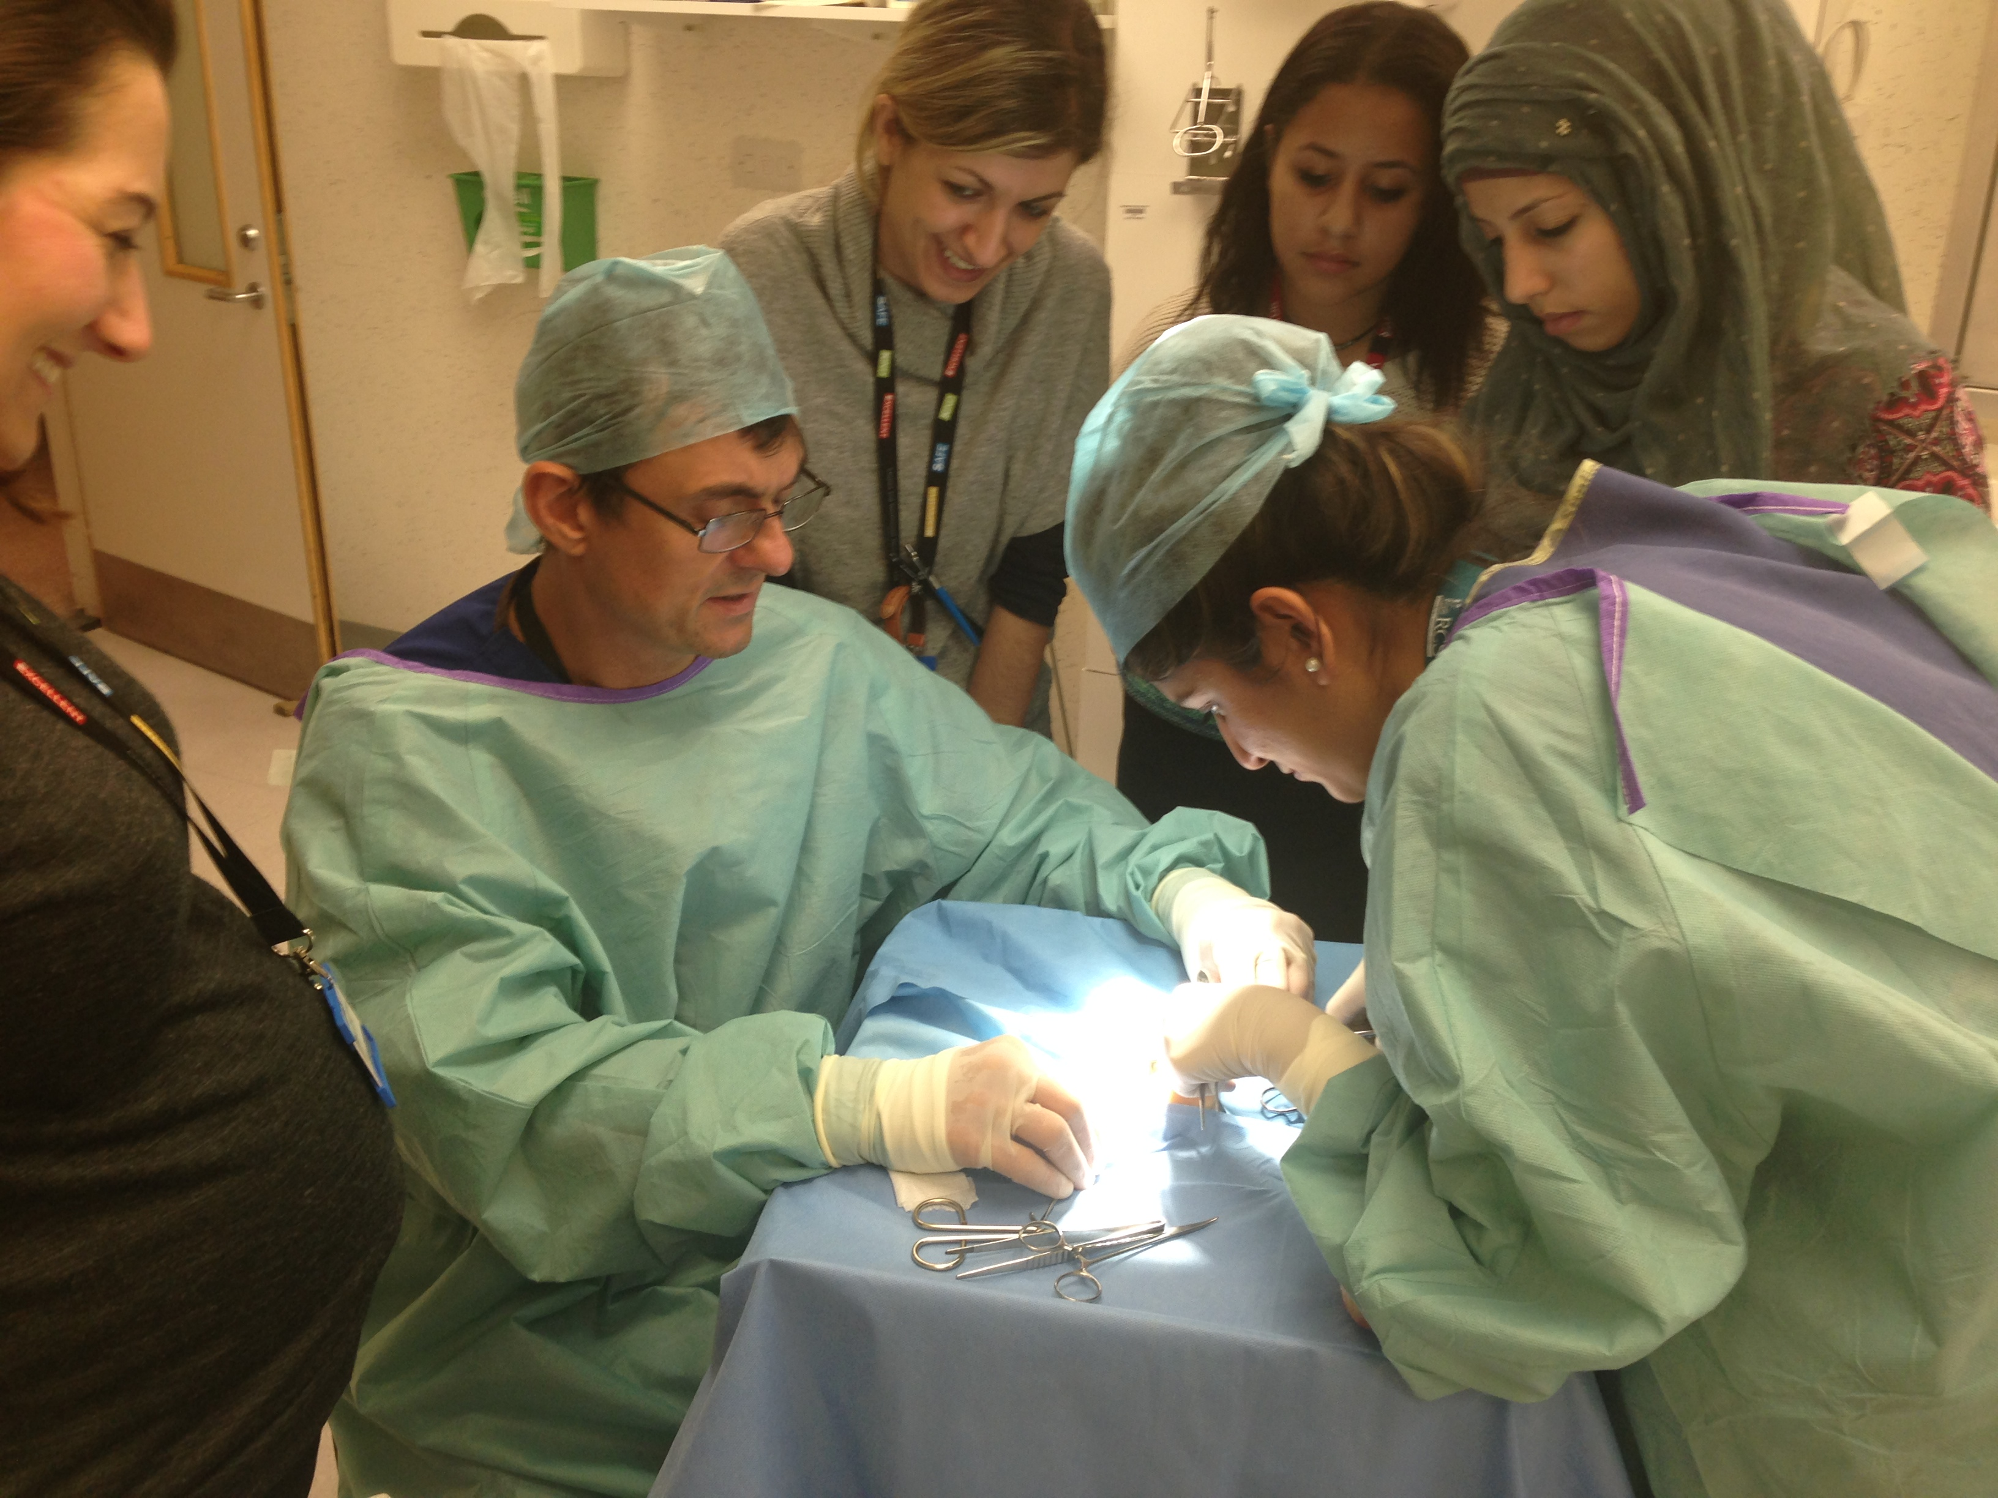
Course Objectives
- This course is aimed at providing entry level Higher Paediatric Surgical trainees ST3 or those trainees returning after an extended leave of absence eg maternity or research , with an introduction/ revision of key skills and topics required for higher paediatric surgical training program in the UK and NI.

Course Dates : Thurs 8th and Friday 9th August 2019
Venue :
- Clinical Practice Centre Chelsea & Westminster NHS foundation Trust, 369 Fulham Road, Chelsea. London. SW10 9AH

Faculty : Simon Clarke ( Consultant Surgeon & Course Director) ; William Sherwood ( Consultant Paediatric Surgeon ); Amanda Macabe ( Consultant Paediatric Surgeon ) ; Georgina Malakounides ( Consultant Paediatric Surgeon)-; May Bisharat ( Urology Fellow) ; Yew Wei Tan ( RCS post CCT Colorectal Fellow) ; Costa Healy (Consultant Surgeon); Niamh Geoghegan (Clinical Nurse Specialist Continence) ; Katie Wessely (Consultant Paediatric Radiologist) ; Carmen Sofia Chacon ( Research Fellow ) ; Alex Scarlett ( ST6) ; Kate Bradshaw ( ST7) ; Stavros Loukogeorgakis ( ST6) ; Helen Carter ( Surgical Care Practitioner) ;
Eduadmin@chelwest.nhs.uk or Tel : 020 7351 8971

Topics Covered:
- How to engage with the ISCP effectively
- How to prepare for your ARCP
- How to complete a discharge summary and clinic letter
- Running a ward round effectively / Learning how to prioritise
- Booking and facilitating a theatre list for emergency , general , urology and Oncology lists
- Operating theatre behaviour
- How to give an effective Rectal washout
- How to do a suction rectal biopsy
- Basic surgical skills eg bowel anastomosis & stoma formation
- Managing the acute neonate from taking referral to booking case including transfer and liaising with consultant on call
- Gastrostomy & jejunostomy tube management : tips and tricks
- Catheterising neonates and small infants : tips and tricks
- Xray interpretation eg NEC perforation , Upper GI contrast for Malrotation
- Management of acute scrotum from referral to surgery
- Management of intussusception reduction
- Suprapubic catheters
- How to avoid burn out / looking after your health as a Specialist Trainee
- Difficult inpatient / outpatient scenarios / on call communication skills
- Management of the patient with ingested foreign body

