BAPS CONGRESS EDITION REVIEW FOR WEBSITE

Journal of Pediatric Surgery 2024 – BAPS Congress Edition

Mark Davenport

It is the month of May and future accepted contributors (oral and poster) for this year’s Congress in Sheffield are even now feverishly counting the days to the deadline for submission for possible publication in the Journal of Pediatric Surgery. It’s Monday June 3rd (very auspicious day incidentally) by the way and all submissions have to be complete, agreed by all its authors and on Kate’s metaphorical desk by close of play.
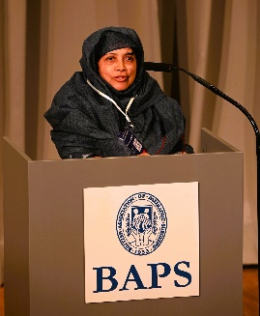
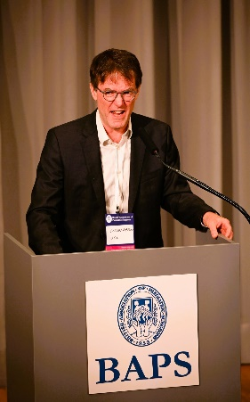
Notwithstanding this, it is worthwhile looking back to last year’s crop and what was actually accepted to give you an idea of the content and the standard. Invited lectures are usually a shoe-in - if the lecturers can get their act together (not as simple as you might think actually). So, we had Prof. Simon Eaton’s JPS Lecture (“I Walk the Line: Between Basic Science and Paediatric Surgery”) of how a simple biochemist from the North-East corner of England arrived in the hallowed surgical halls of Great Ormond Street Hospital and his subsequent rise to the very top benefiting the research output of a generation of fellows and indeed professors. This was complemented by a transcription of the Hugh Greenwood Lecture by Prof. Tahmina Banu with “Revising Destiny – Surgical Care in Birth Defects” on the extraordinary problems treating such problems in Bangladesh.

Beyond that we had another 24 papers that made the grade, not only from UK surgical departments such as Birmingham, Bristol and Newcastle but also from distinguished overseas institutions such as CHOP and Boston Children’s Hospital in the USA, and large Asian centres in Japan and Malaysia.
Elsevier, the publishers, have released a selection of these papers for free and immediate download as a courtesy to BAPS members. Let’s see what you think of them……. There is Bruce Jaffray’s pushback paper disputing the need for fancy lengthening techniques in long-gap oesophageal atresia and the GOSH team’s review of their huge experience on oesophageal replacement.

- Phillips L, Jaffray B. What Proportion of Children With Complex Oesophageal Atresia Require Oesophageal Lengthening Procedures? J Pediatr Surg. 2024 Feb;59(2):187-191

- Mayer A et al. Short and Medium Term Outcomes of Open and Laparoscopic Assisted Oesophageal Replacement Procedures. J Pediat SUrg 59, ISSUE 2, P192-196, FEBRUARY 2024

- Sutton L et al. Open and Thoracoscopic Aortopexy for Airway Malacia in Children: 15 Year Single Centre Experience J Pediatr Surg VOLUME 59, ISSUE 2, P197-201, FEBRUARY 2024

- Laje P et al. Surgical Management of Central Lymphatic Conduction Disorders: A Review J Pediatr Surg VOLUME 59, ISSUE 2, P281-289, FEBRUARY 2024

Journal of Pediatric Surgery guidelines | BAPS Congress



Edited by,
Prof Mark Davenport
UK and Ireland Editor of the Journal of Pediatric Surgery

